## Concept

### The Basic Idea

Our City (working title) is an arcade driving simulator in the open world with RPG elements. The whole city is located on the island. The game is inspired by GTA and Driver games concepts. The game will not have a multiplayer mode, only a singleplayer mode will be implemented. A player can only move around the city in his vehicle and will be completing a set of missions, which are connected to the story line. A player will collect game’s currencies, to buy add-ons for his vehicle and other items. After all of the missions will be completed, the player will leave the city and the game will end.

### Story Concept

The “Virus V” was created as an unsuccessful experiment of the governmental project “Salvation” for creating anti-cancer drug. The development was taking place on the island, where mostly project related workers were living, but because the project was secret, there we’re normal citizens as well, who didn’t know about existence of this laboratory experiments on the island. From the very start the infection penetrates nervous system destabilizing motor functions and hence senility. The “Virus V” is distributed by breathing, and in order to prevent global epidemics, the island’s been closed and the regime of quarantine was set up. The only terrestrial entrance to the island – the bridge is controlled by Special Forces, who are called “Bridge Watchers”.

The governmental preparations allow people to live in their homes, which are really working as bunkers, with have its own stations for regenerating oxygen with anti-mutational ingredients, to prevent illness’ mutation. Vehicles are adopted to be filled by this oxygen is special facilities, which are called oxygen stations.

The protagonist appears on the island with a feeling of amnesia, but as time goes by, he remembers most forgotten parts. He remembers that once he had a girlfriend, and that she left the island before it was closed. So he’s making efforts to leave the island and meet her again.

When he’s almost finished making necessary preparations to leave the island, he realizes that the Bridge Watchers had disappeared, and he rushes to the other side of the bridge.

He’s feeling happy, but soon he realizes, that the Virus V escaped from the island and the infection became Global. But he still believes that he will find his girlfriend, and here the game ends.

### Processing

The Game will be processed in 3D; camera view will be fixed with a mouse controlled rotations. The island will be created as a set of squares, with building filled in necessary places. Around the island there will be water, which is going to work as a border for possible vehicle’s positions.

### The Island

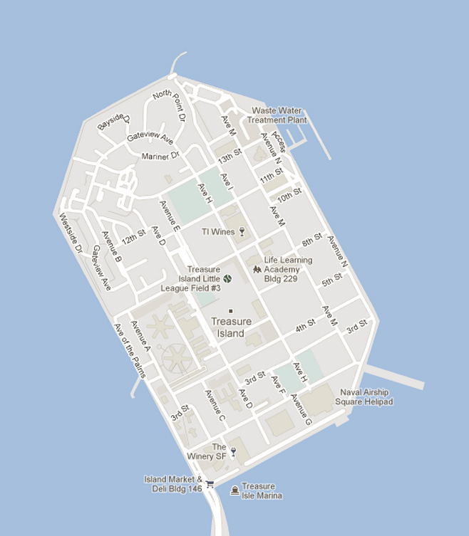

Example of the Island’s Plan

The player will have a free driving mode around the city, and he will contact with AI controlled vehicles. Most of AI controlled vehicles will respect the driving rules. Water around the island will be used as a border for allowable driving routes. The bridge that connects the island with the main land will be long enough, to disable possibility of crossing the water to the nearest land.

### The Vehicle

The player will have his main vehicle that could be upgraded to more advanced versions. For some missions different vehicles will be used.

### User Interface

#### Main Menu

Main menu consist of design elements and basic modes, including Singleplayer, Options and Exit.

#### HUD

In the bottom-left corner is the mini-sized map of surroundings, in the top-left corner is a minimized version of the communicating device, which can be rolled out. In the top-middle of the screen is a timer that usually appears in the missions. In the top-right corner of the screen is the oxygen bar, which is follow by notification shortcut. In the bottom-left corner is speedometer and tachometer.

### Game Modes

There will be two main game modes, including free driving mode, where the player can drive around the city. And a mission mode, where he has to do actions according to each mission. Missions will be implemented as checkpoints, races, etc.